John Clifford School Passport
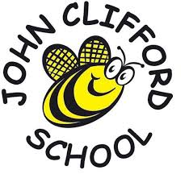
This year I am going to be in Year 5

My Class is Buddelia Class
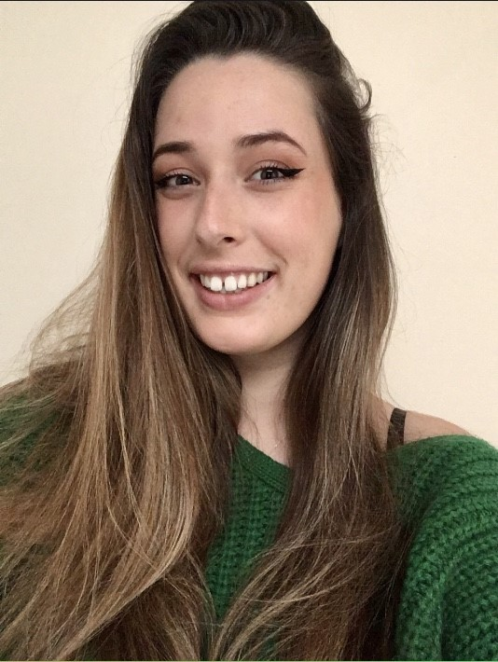My Teacher in is Buddelia Class

Miss Crook
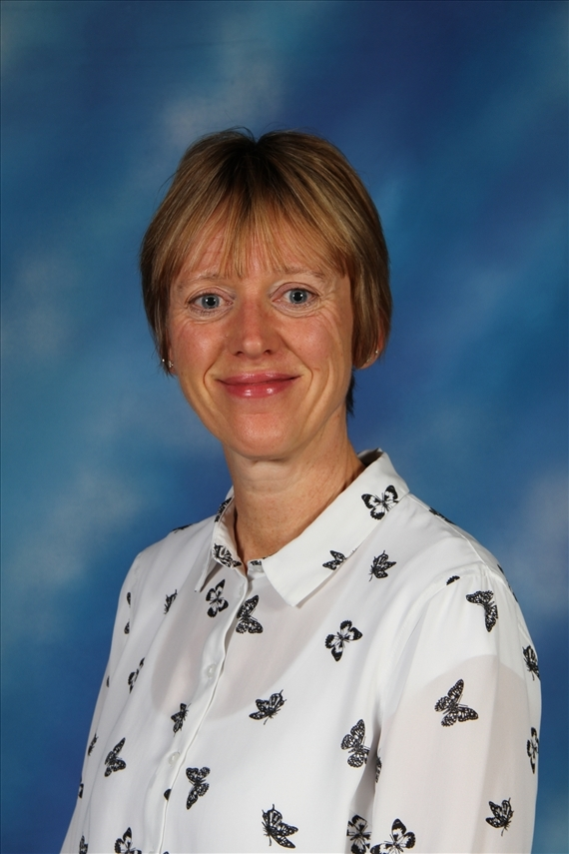The Teaching Assistant working in Year 5

Mrs Hosker
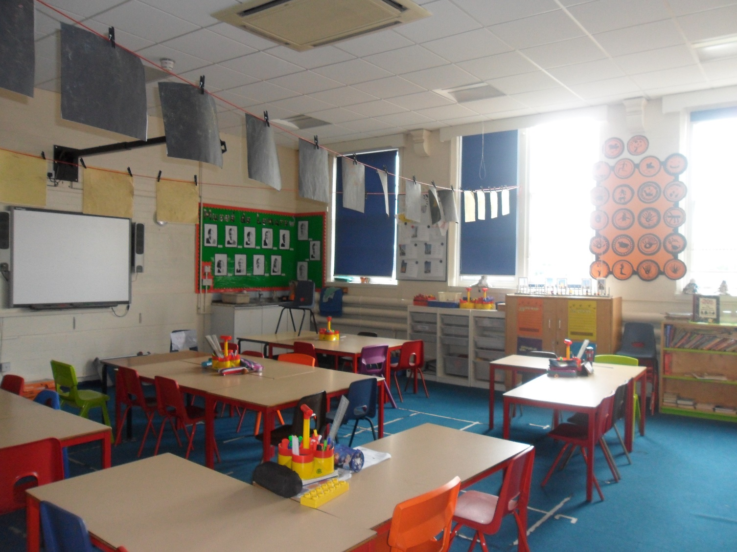
My Year 5 Classroom – Buddelias

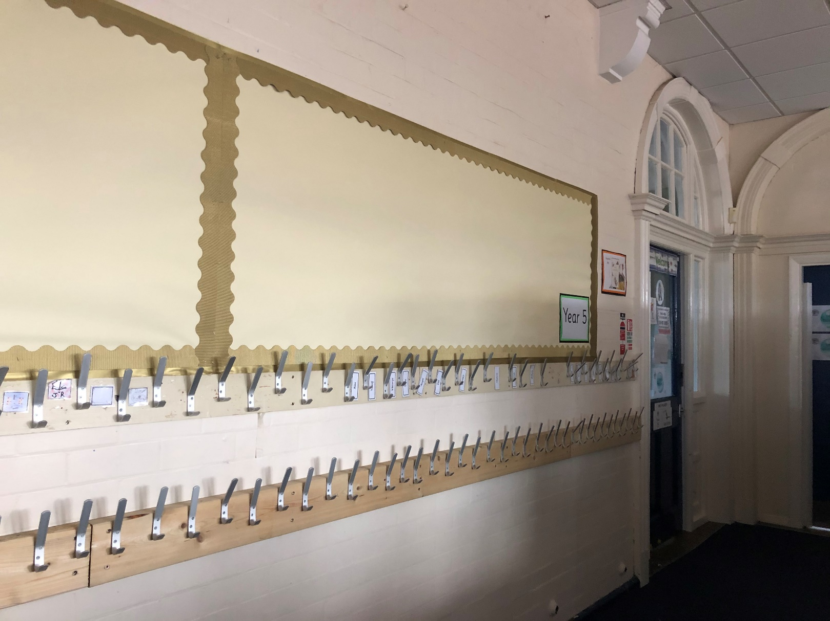
My Cloakroom

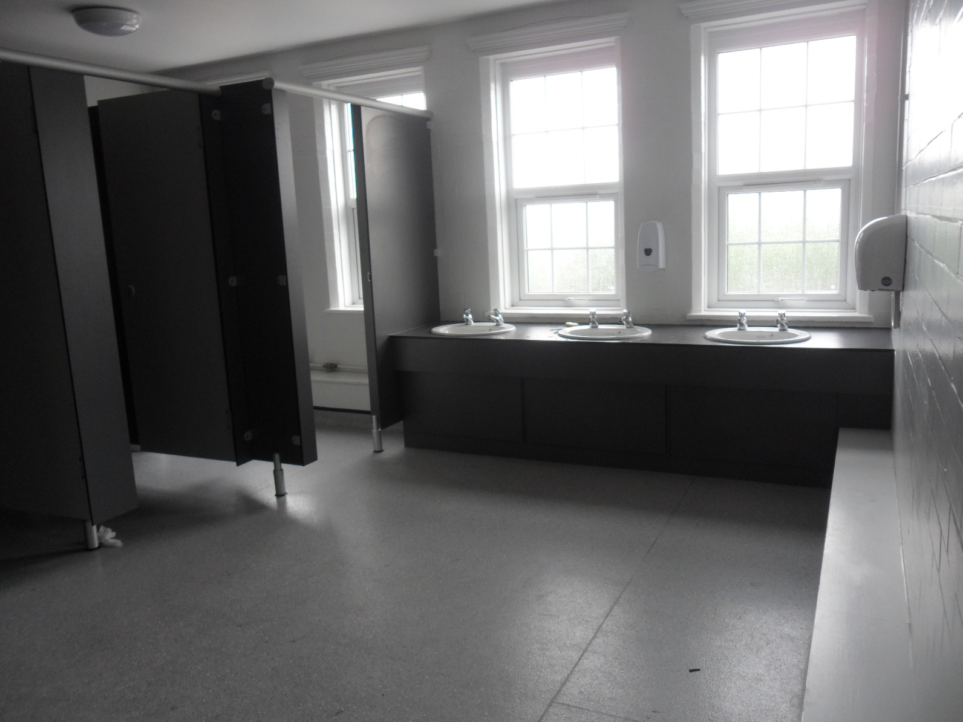
The toilets I will use.

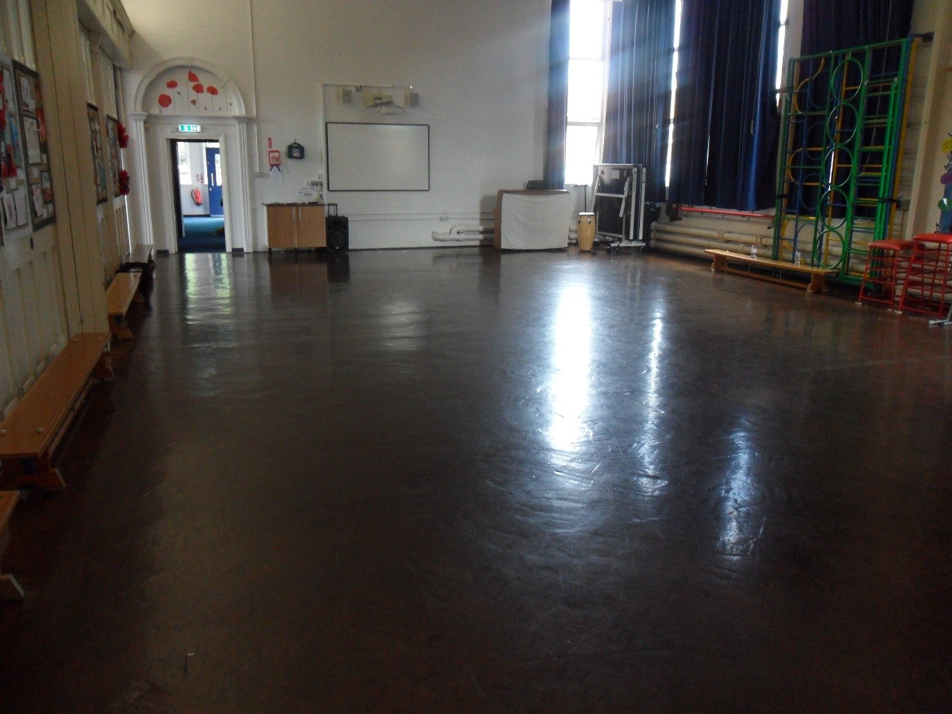
The Junior Hall

