John Clifford School Passport
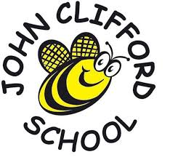
This year I am going to be in Year 5

My Class is Allium Class
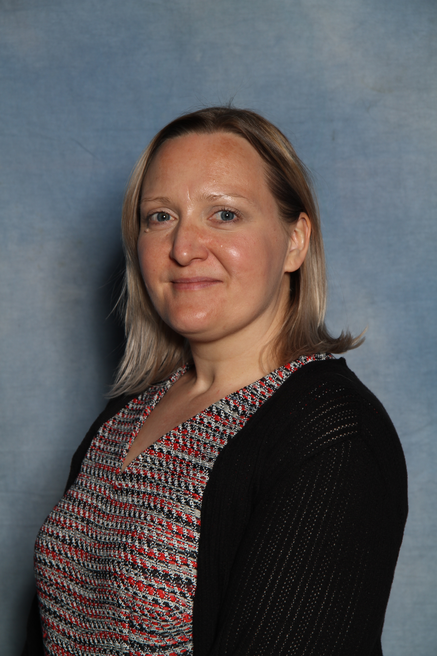My Teachers in Allium Class are
Miss Kyle Mr Mitchell
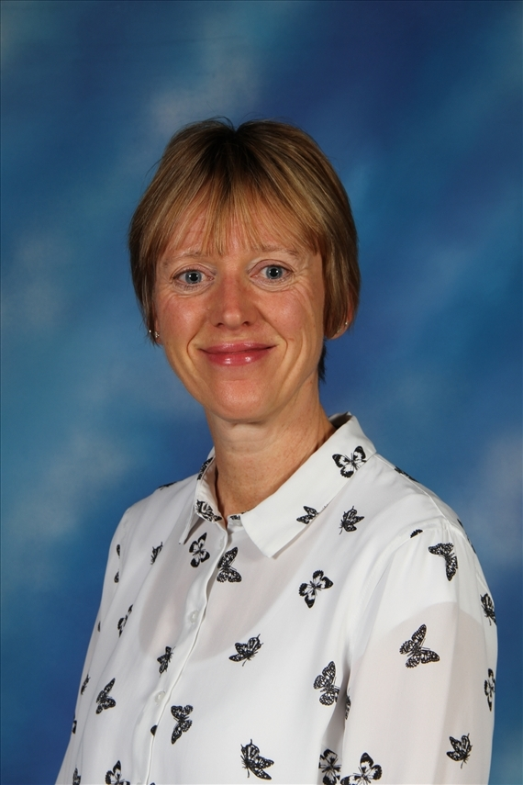
The Teaching Assistant working in Year 5

Mrs Hosker
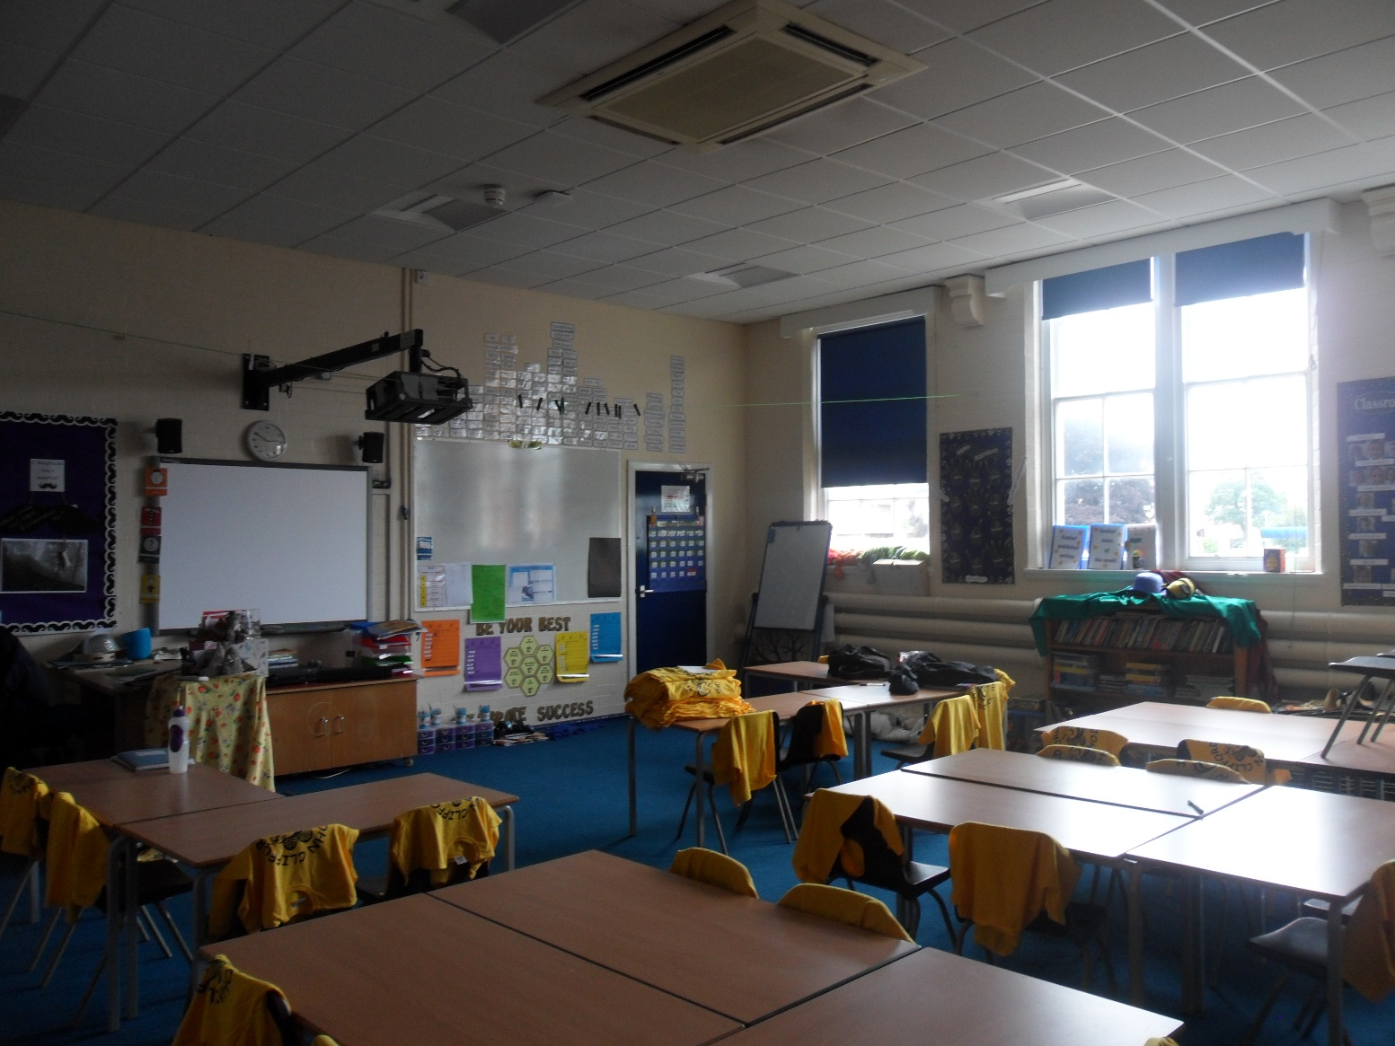
My Year 5 Classroom – Alliums

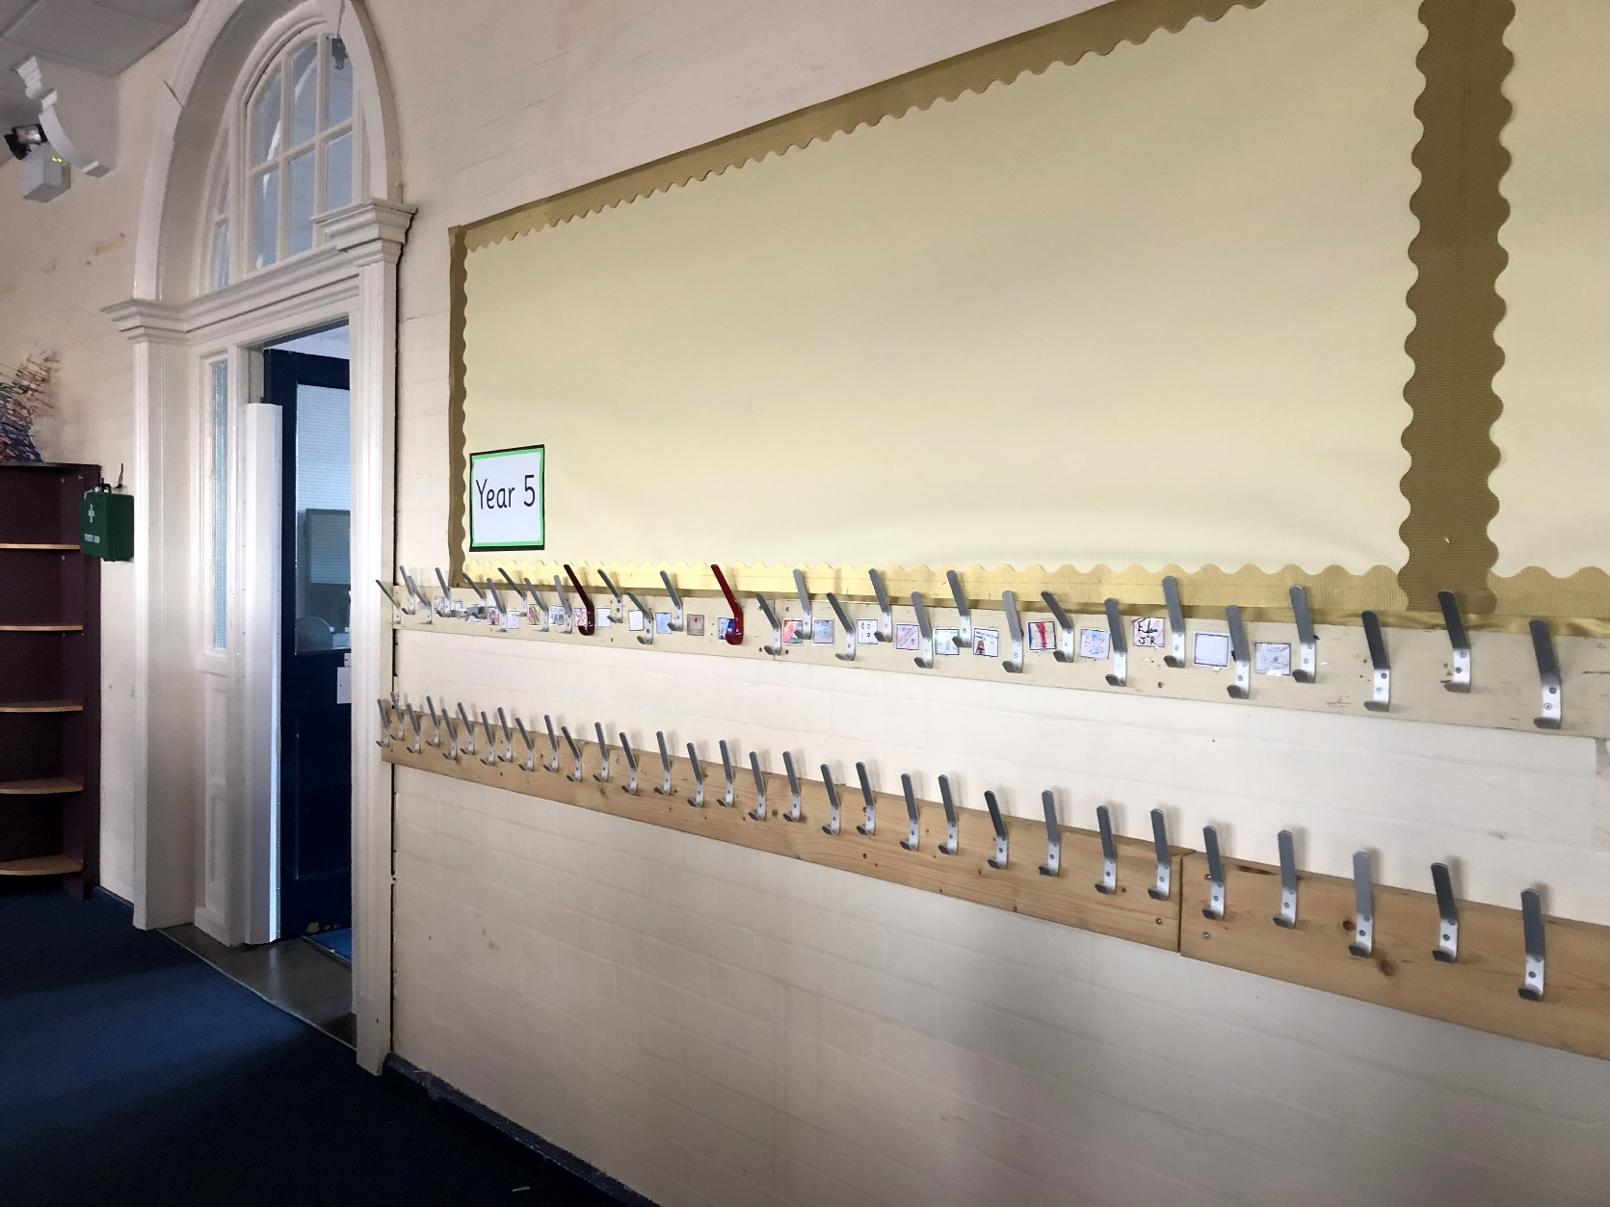
My Cloakroom

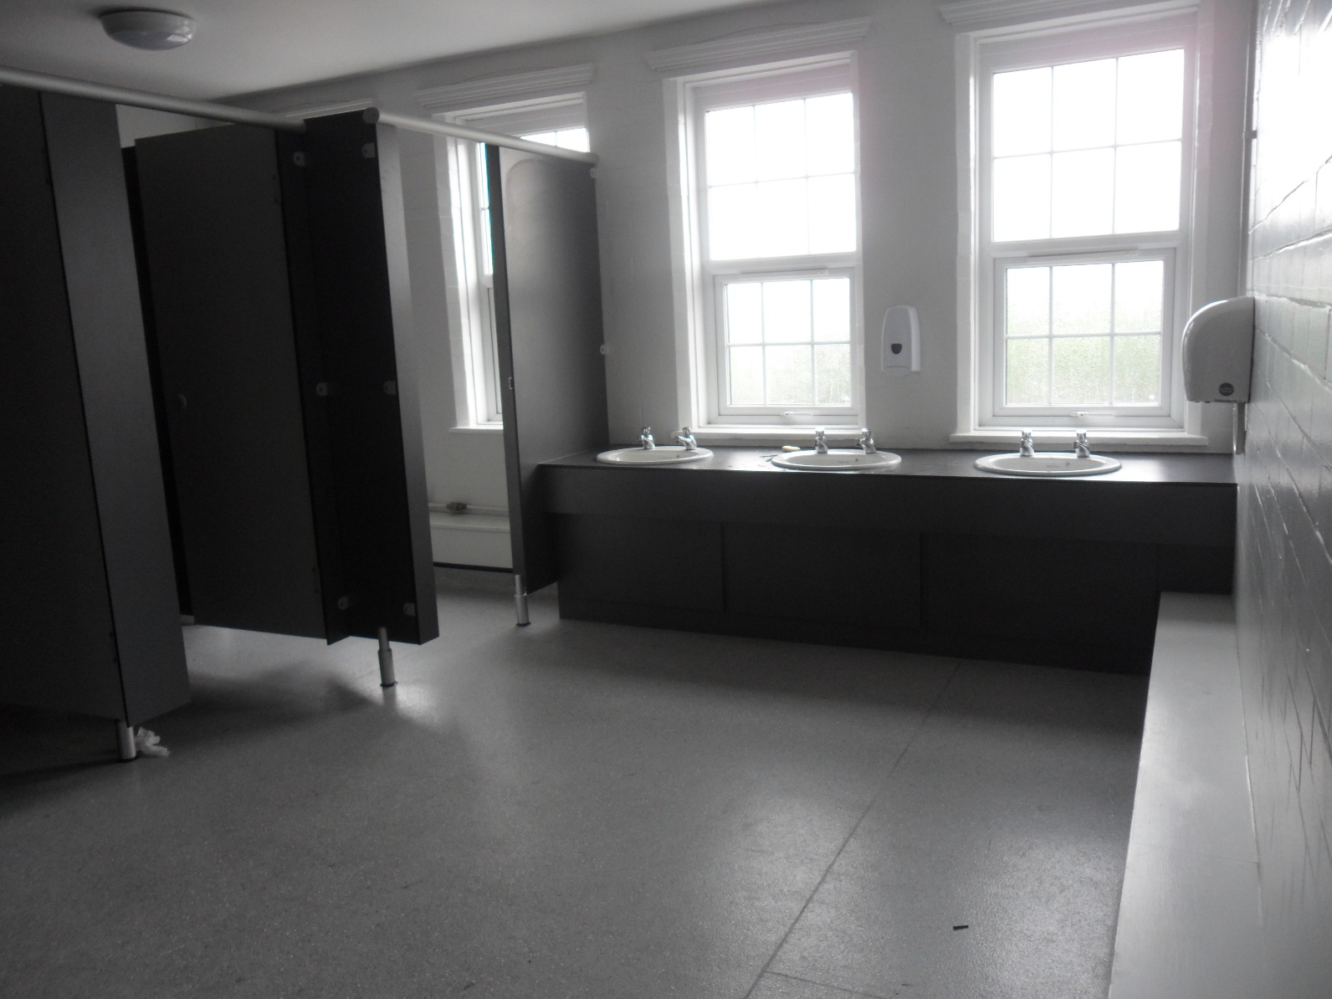
The toilets I will use.

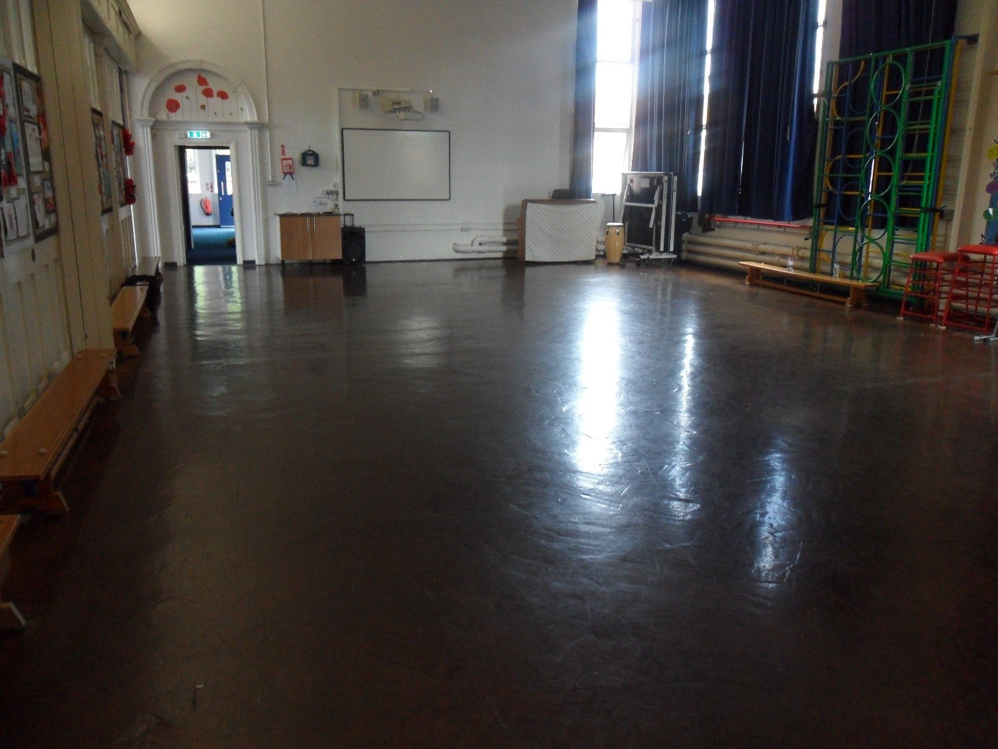
The Junior Hall

