John Clifford School Passport
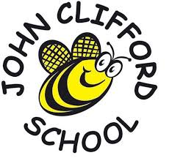
This year I am going to be in Year 3

My Class is Violet Class
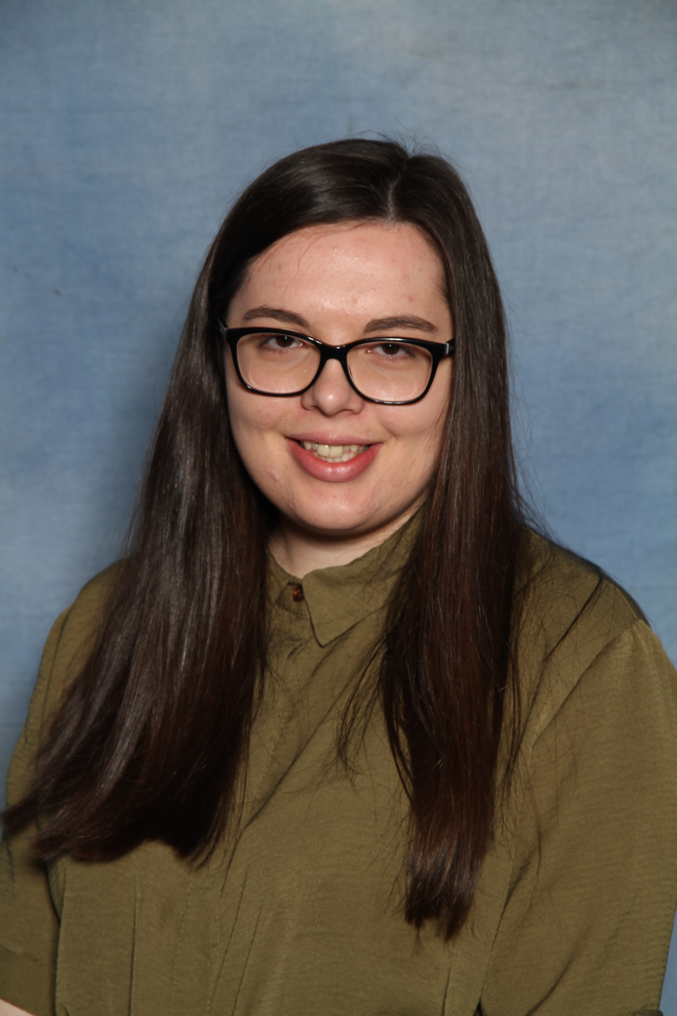My Teacher in Violet Class

Miss Joynes
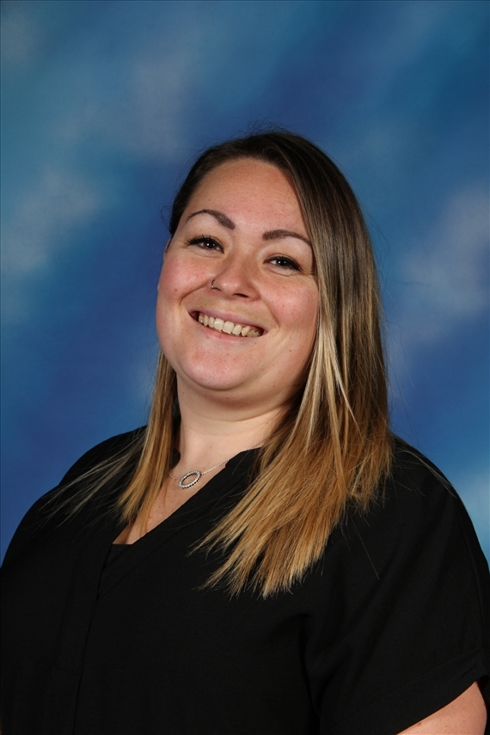The Teaching Assistant working in Year 3
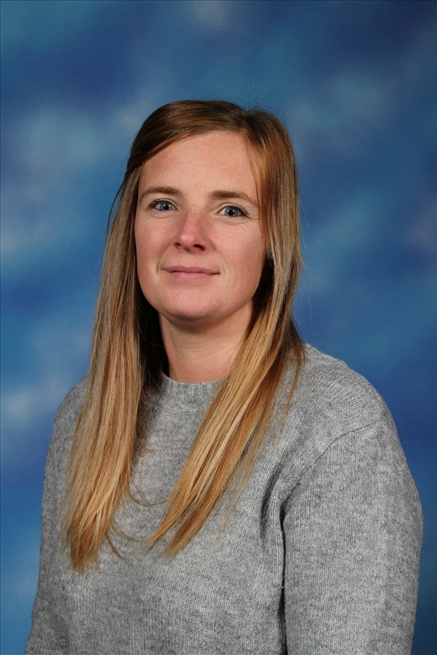
Miss Wilson Mrs Jacques
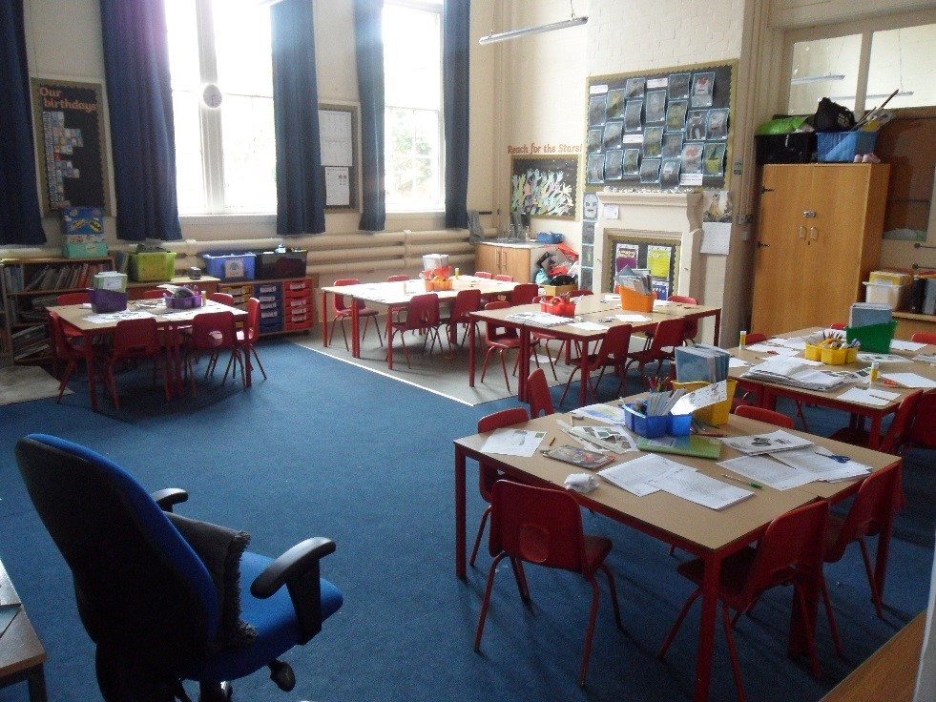
My Year 3 Classroom – Violets

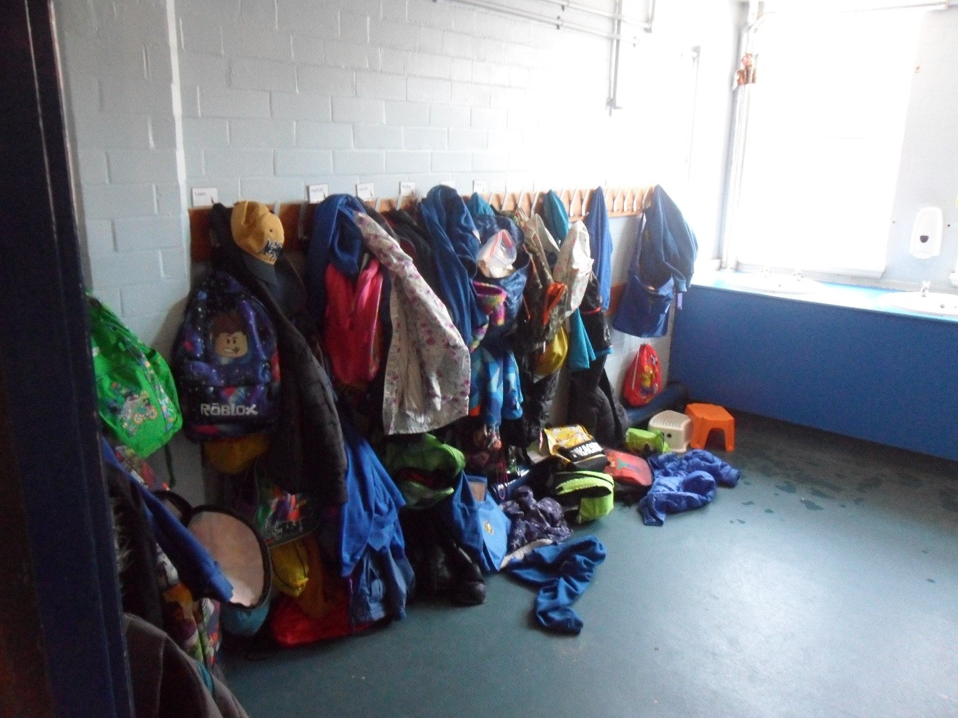
My Cloakroom

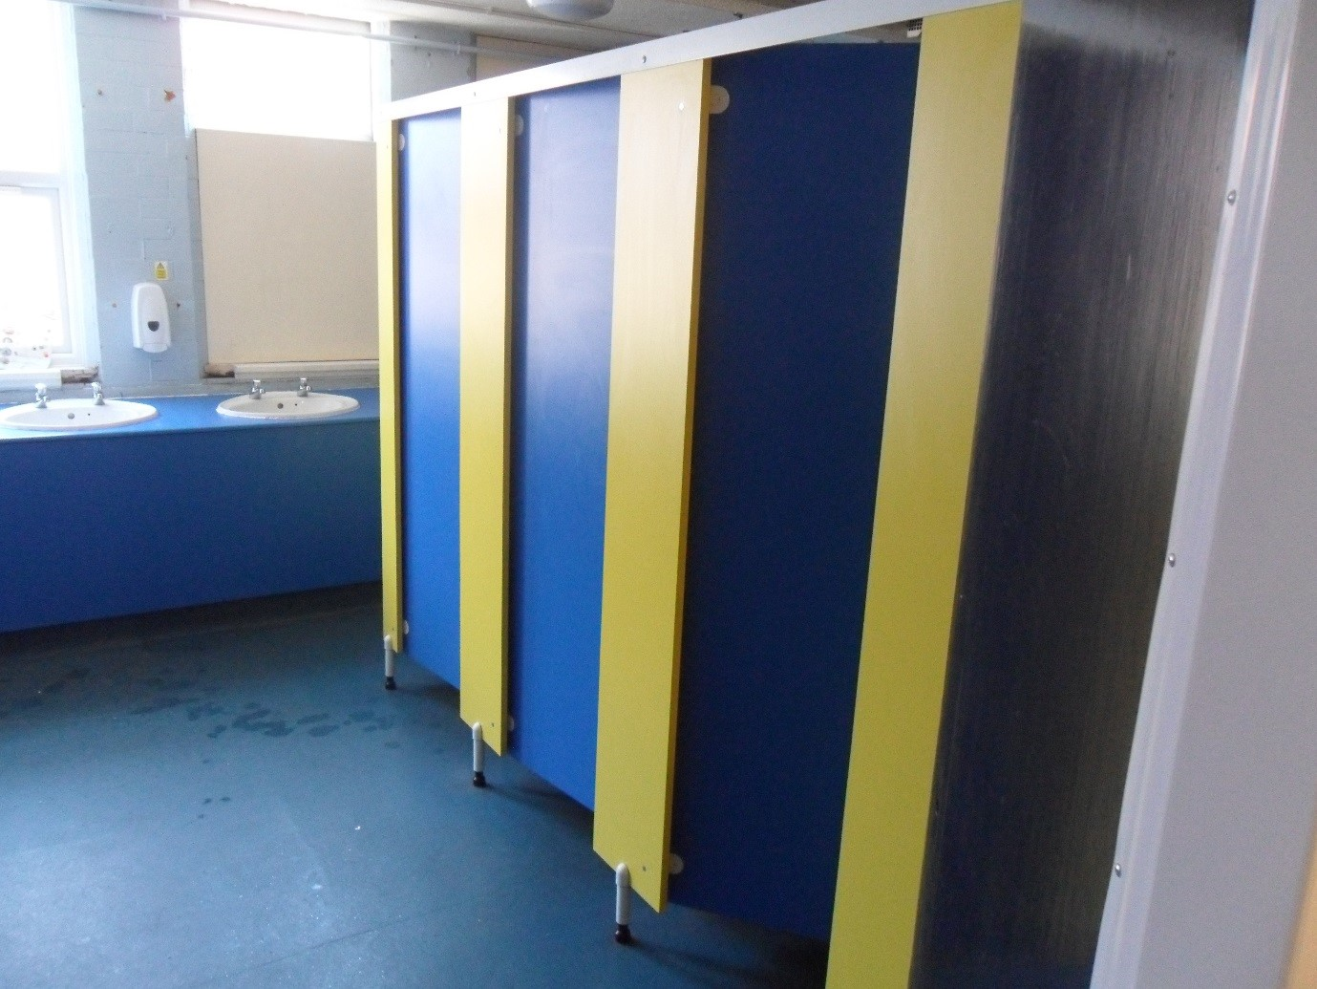
The toilets I will use.

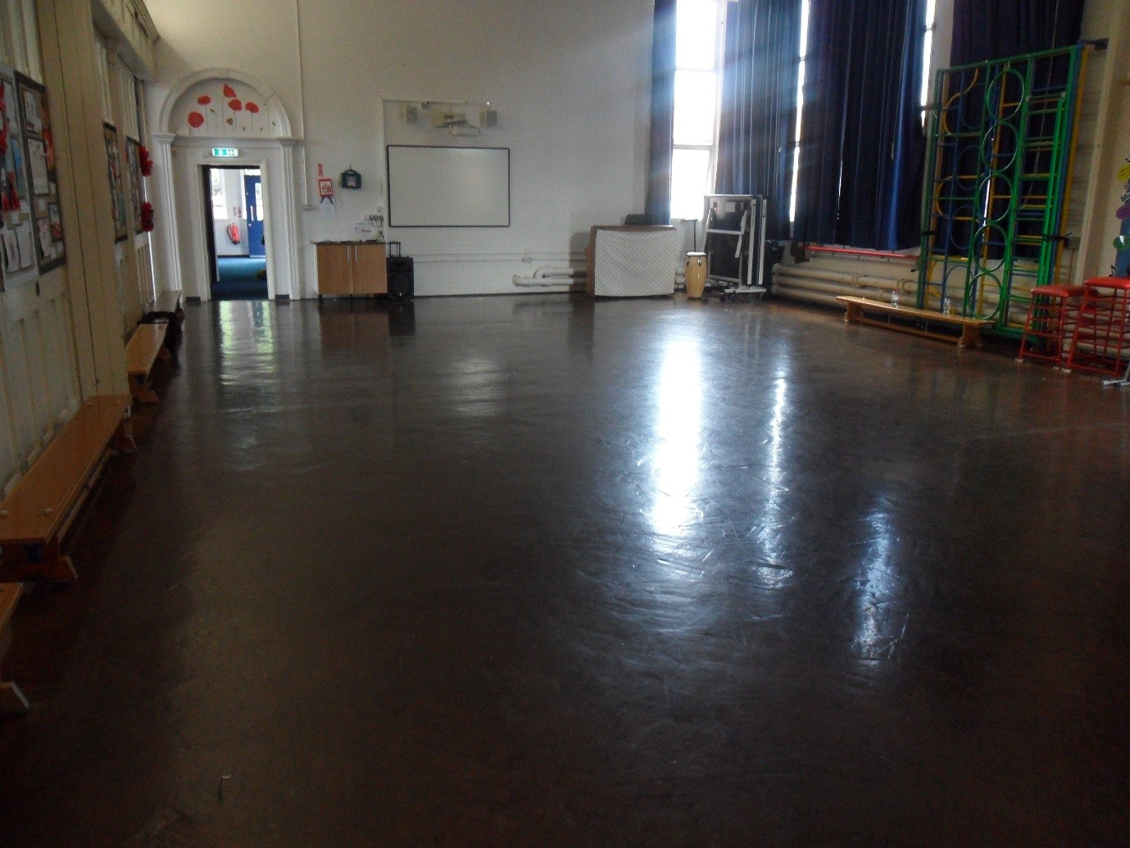
The Junior Hall

