John Clifford School Passport
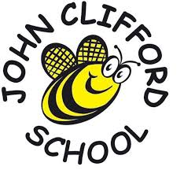
This year I am going to be in Year 4

My Class is Heather Class
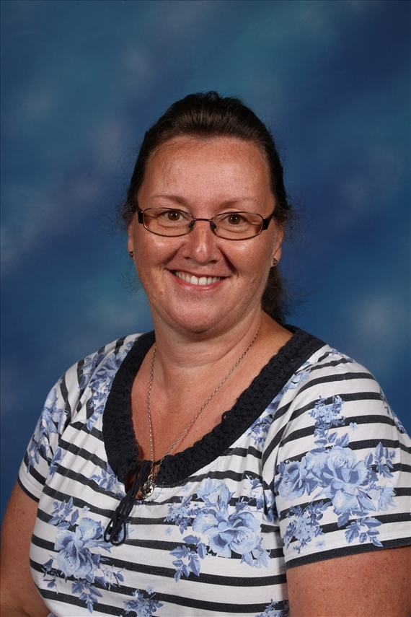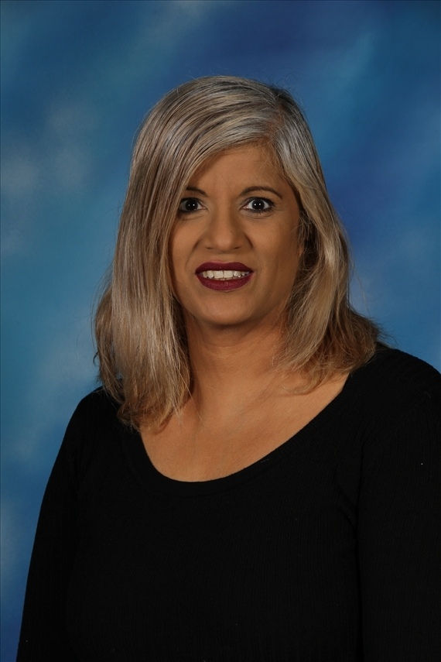My Teachers in Heather class are
Mrs Pounder Mrs Argent

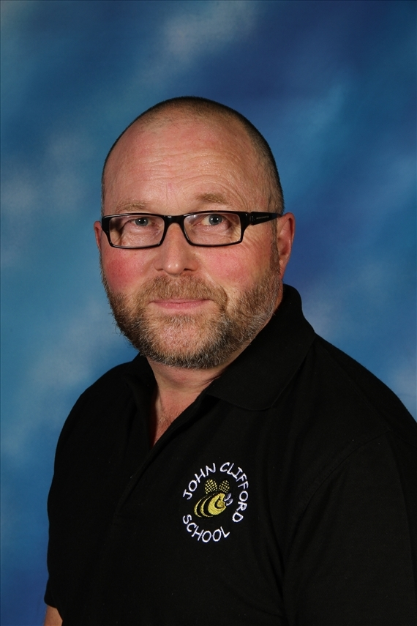The Teaching Assistant working in Year 4

Mr Barber
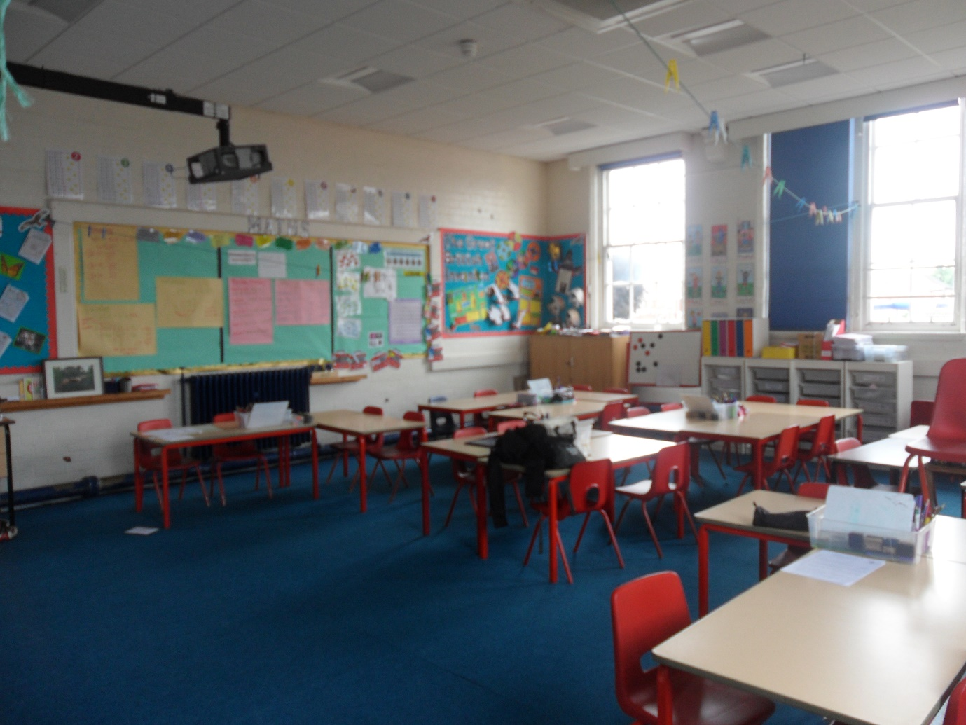
My Year 4 Classroom – Heathers

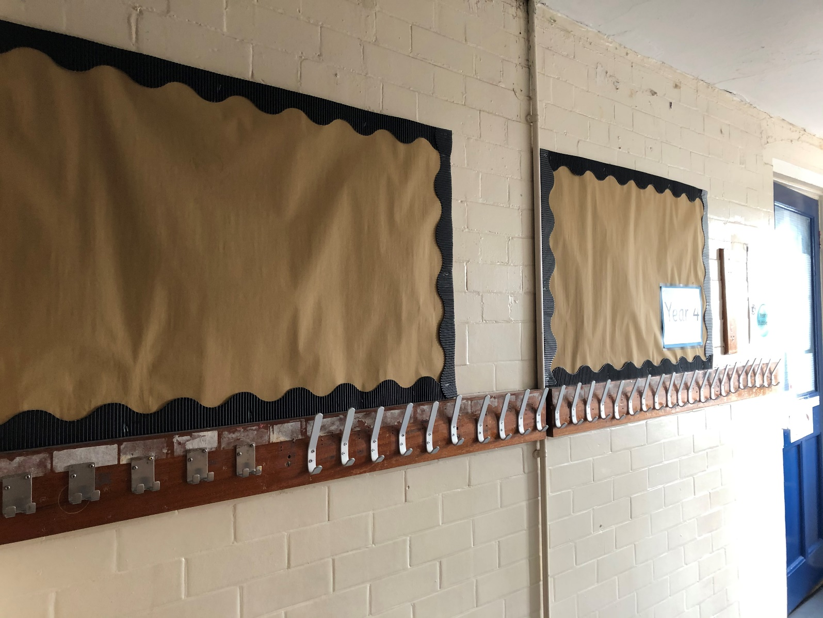
My Cloakroom

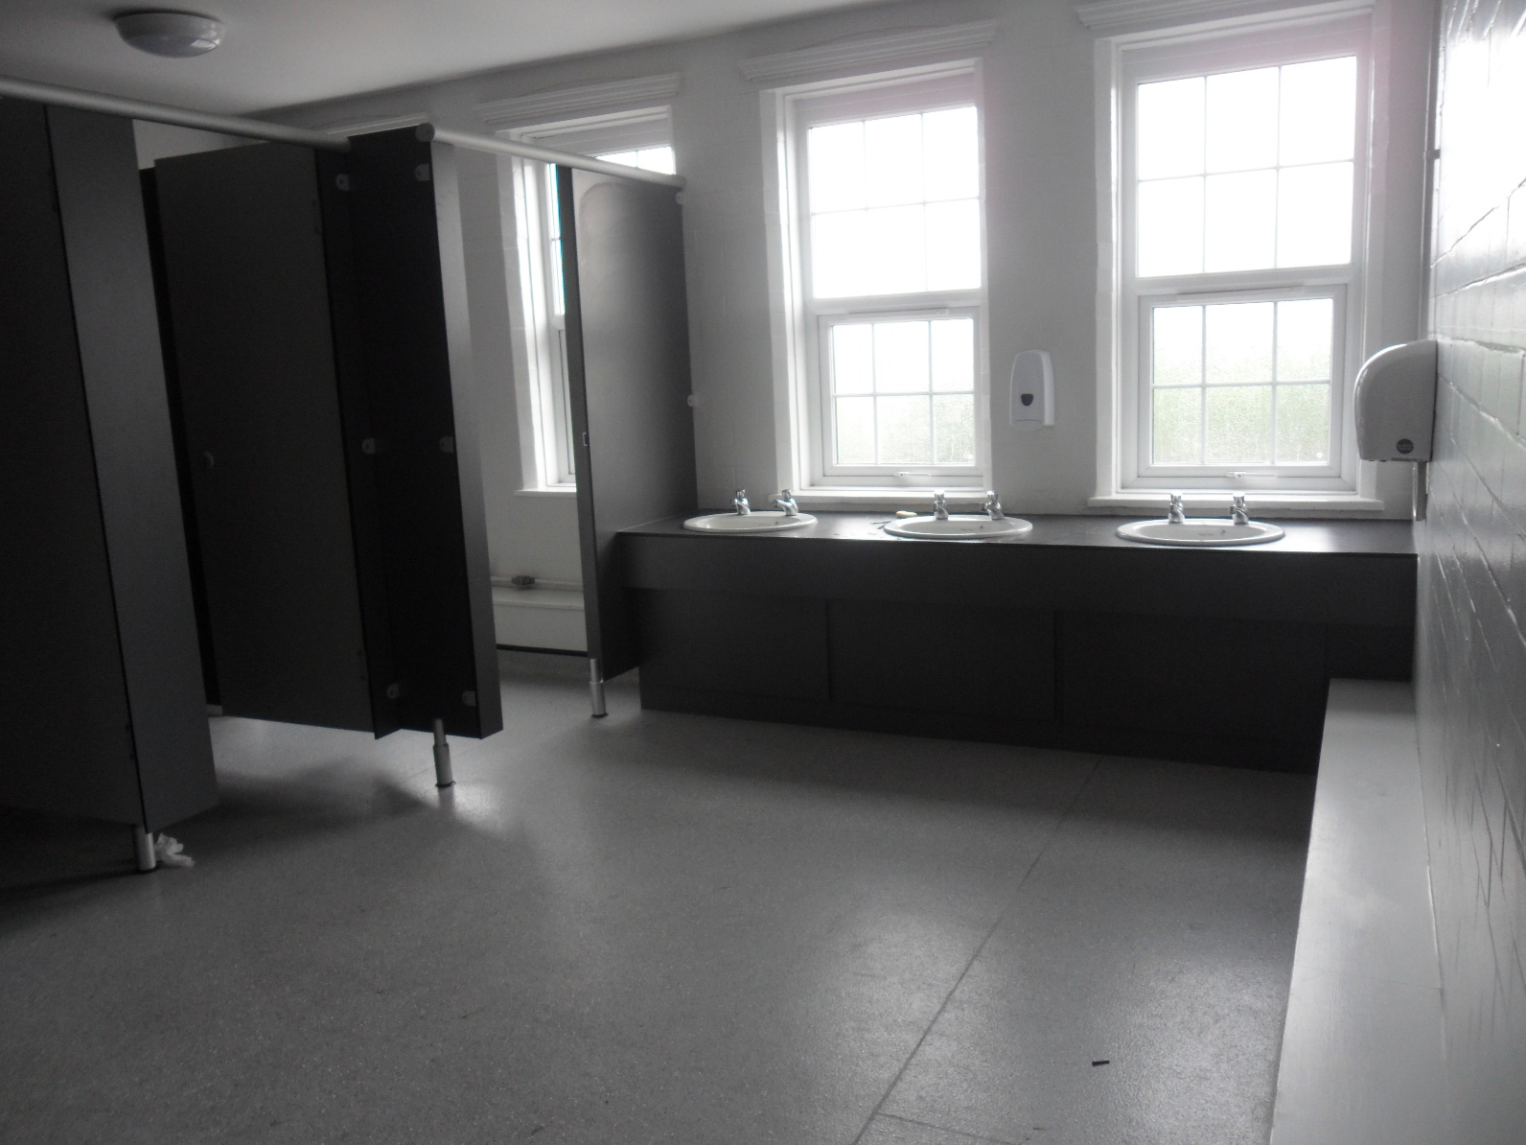
The toilets I will use.

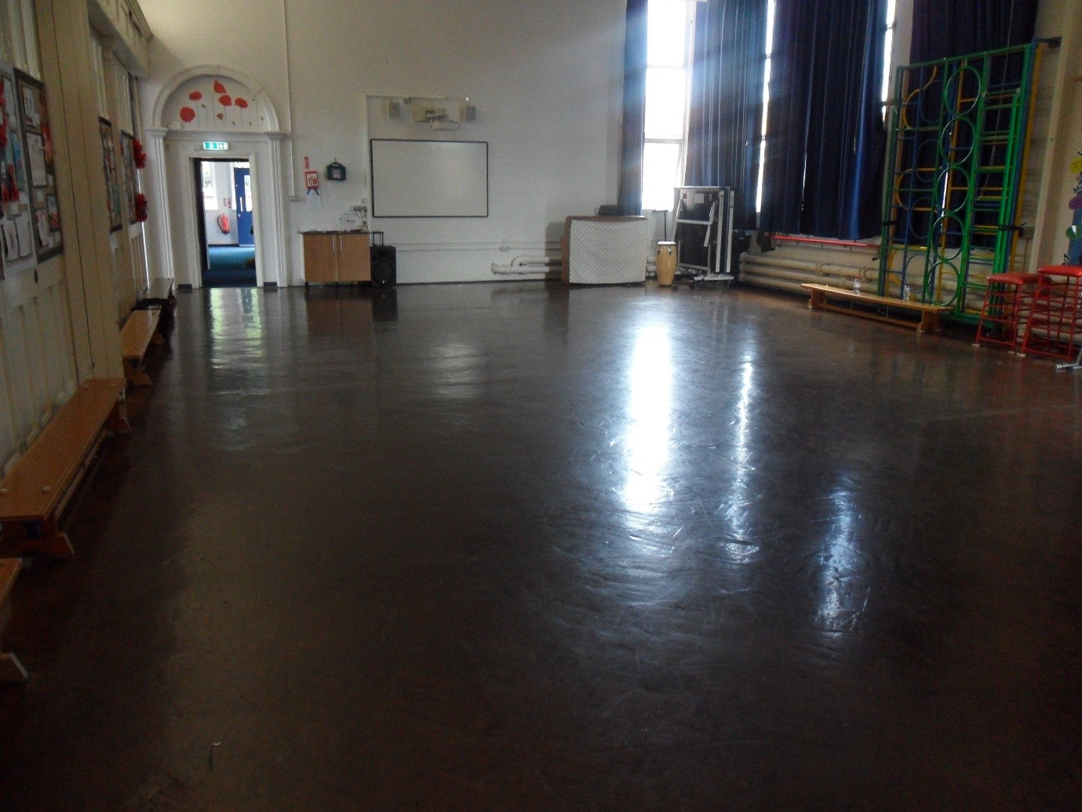
The Junior Hall

